Spring Boot Proposal for Final Project

Overview:

This Final Project spans the final few weeks of the bootcamp, including 1-2 weeks for design and approval, and two full weeks for implementation. The Project will implement a RESTful Web API with full CRUD (Create, Read, Update and Delete) operations on a MySQL database.

The Spring Final Project is worth 800 points, and accounts for 25% of your final course grade.

Instructions: For this assignment, you will begin brainstorming and creating a proposal for your Spring Boot Final Project. Begin brainstorming ideas and come up with one you (and your group if you choose) feel fulfills all the requirements listed below. Your proposal will need to be approved during class in Week 16 by your instructor or by a mentor, and finalized by the end of Week 16. Below, you will find a simple template for your proposal.

NOTE: You will not be turning anything in for this assignment this week.

Requirements:

Project Requirements:

1-person Project:

• Database design which contains at least 3 entities and 3 tables

• Contains all CRUD operations (Create, Read, Update & Delete)

• Each entity should have CRUD operations with one entity having all 4 CRUD operations (Create, Read, Update & Delete).

• Contains at least 1 one-to-many relationship

• Contains at least 1 many-to-many relationship with one or more CRUD operations on this relationship

Required: REST Web API Server tested through Swagger, Postman or AdvancedRestClient (ARC) or a front-end client.

Proposal

Project Participants:

List all group members here. Just write your name if you are working solo.

Antonio Cousin, Jr.

Title: A Storytelling Database

Executive Summary:

This project is intended to track and update information for series of books, focusing on the initial information needed identify specific information about the series, the books within it, and the genre of the series itself.

Initial Features:

Entities: Series, Genre, Series_Genre, Book

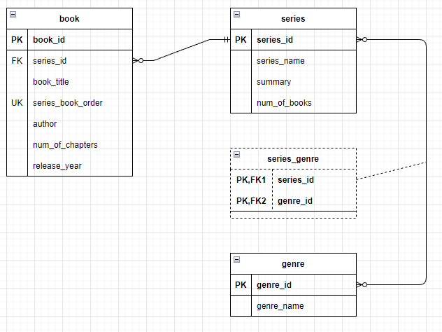
A user can perform the following operations:
- Browse all Series (GET on Series)
- Add a Series (POST in Series)
- Browse Series by genre (GET on Series with genre specified)
- View Books in a Series (GET on Book using primary key in Series)
- Add Book to a Series (POST in Book, adding foreign key linking to Series)
- Update Book order in series if new book is chronologically earlier or later in the series (PUT unique key of Series Book Order to proper placement in the series)
- Remove Books from a series and/or genre (DELETE in Book)
- Add Genres for Series (POST in Genre)
- Browse Genres (GET on Genre)
- Link Series with Genre (POST in Series_Genre)

Stretch Goals (to be completed if time allows, or after graduation):

Some planned features to be implemented after the initial features are completed:
- Add entities/tables to check and expand on more advanced information for storytelling information such as:
  - Linking the series with publishing houses
  - Separating Author from Book entity into its own entity
  - Add entity to track word count, average reading time, number of chapters (extracting it from Book entity)
  - Update the code to dynamically track the number of books in the series with the number of entries linked to its primary key in the Book entity
  - Adding a clause to series, book and author entities for the inclusion of images pertaining to the entities (i.e. Book Cover art, Author Photo, Series Cover Art, etc.)

